**Course: Advance Bio Informatics**

**Module Title: Target Identification Strategies**

**Module No: 162**

**Drug target**

Drug target is a protein. It is importance of Target Selection

Protein data has 3-D structure. It has the Info about sequences & structures of proteins.

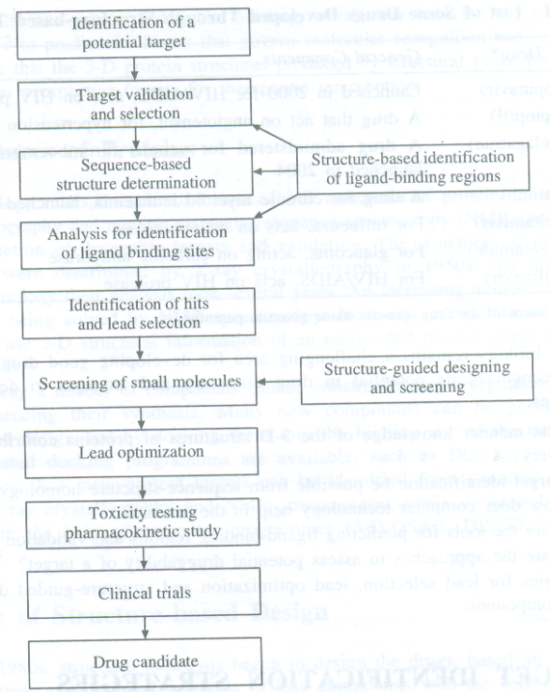

**Methods for Predicting Functional Regions**

* Un-liganded protein is determined
* X-ray or NMR by using Protein & NA DBs
* Information about known 3-D structures

**Molecular Functions**

1. Sequence-based methods: Less accurate Predict important regions MSA
2. Structure-based Sequence structure homology recognition

**Identification of Specific Regions**

20 AAs, each one having specific & fixed position. MSA for structural and functional info. Any changes in position of AAs due to functional requirements may be identified.

**DBs for functional sites**

**PROSITE:** Protein DB, Identifying possible function of newly discovered proteins

**PFAM:** DB of proteins family related sequences in HMMs

**Finding Conserved Region**

* 1. Sequence space
  2. Evolutionary trace method
  3. S-method